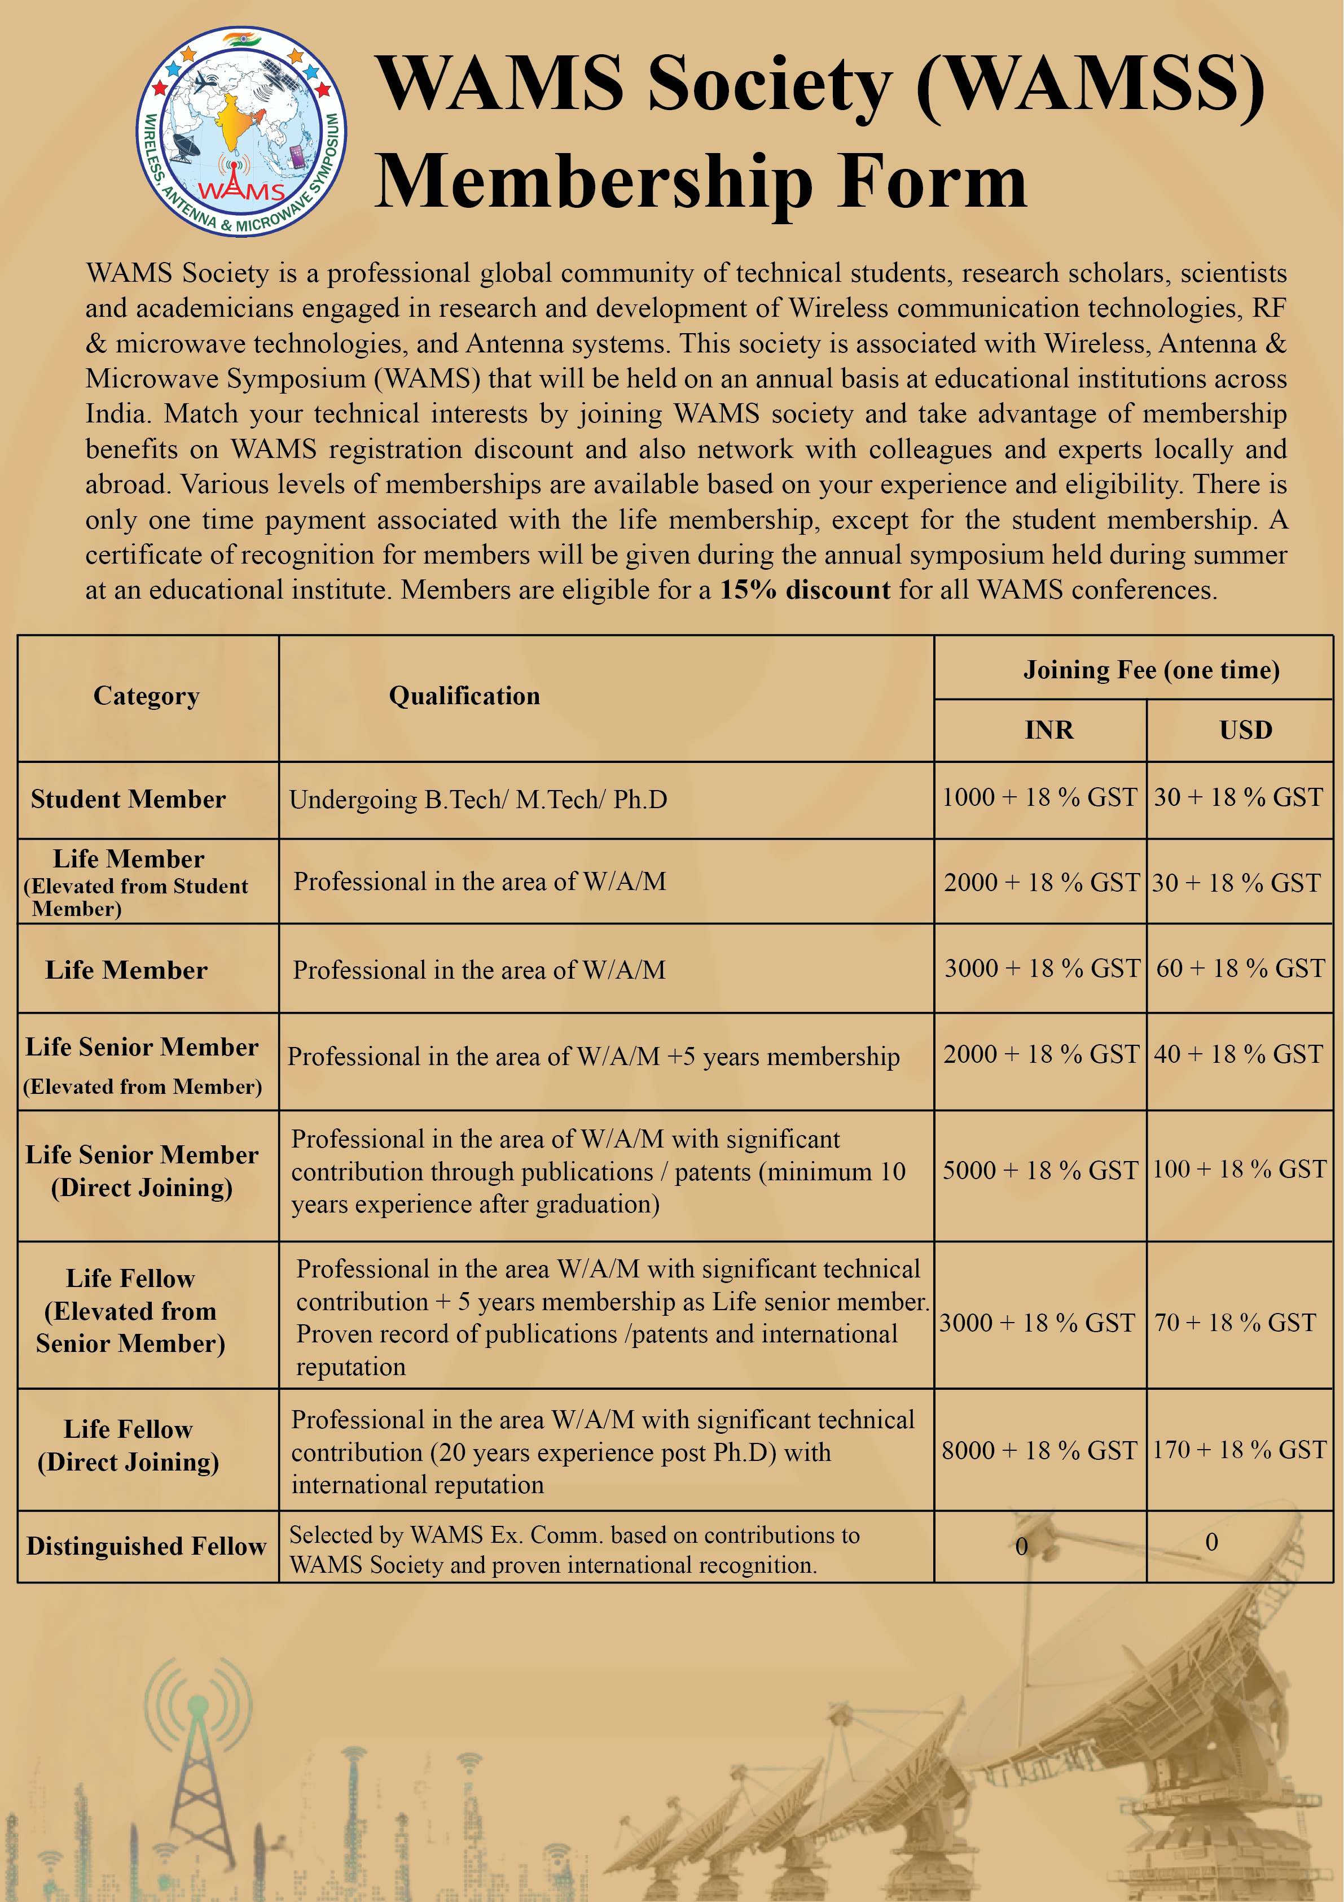

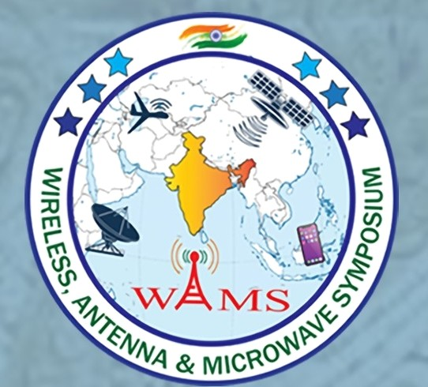 | Wireless, Antenna and Microwave Symposium Society (WAMSS)  Web Site: https://wams-society.com/  Email: wamssocietymember@gmail.com

Membership Applied for (Student Member/Life Member/ Life Senior Member/ Life Fellow) _______________________________________
Name of the applicant (to be printed on membership card) ________________________________________________________________

Current Affiliation ________________________________________________________________________________________________

Date of Birth______________________________ Nationality______________________________________
(Date) (Month) (Year)
Mailing Address_________________________________________________________________________________________________

_____________________________________________________________PIN CODE___________________________

Contact Number: (Mobile)_______________________ (Office) _______________________
Email: ________________________________________________ Alternate Email: _________________________________________
Membership Amount Paid and mode of payment: Transaction Id:
Date of Transaction:
ACADEMIC QUALIFICATIONS | Degree / Diploma | Name of College / Institution | Year of Graduation

PROFESSIONAL EXPERIENCE |  | Designation / Rank* | Organization | Period  From To

MEMBERSHIP OF OTHER INSTITUTIONS AND AWARDS:

SUMMARY OF PROFESSIONAL EXPERIENCE:
(Engineering work/Research Publications)

DECLARATION BY THE APPLICANT

“As a member of WAMS society, I shall follow professional ethics, maintain integrity in research and publications, uphold the cause and dignity of the society, endeavour to be objective in my judgment and strive for the enrichment of human values and thoughts. Further, as a member of WAMS society I will advance the objects of the society as far as they shall be in my power.”

Witness my hand this _______________________day of ____________________ _________________________
Date Month Year

Signature ______________________
Date:

- Membership Review & Approval

The membership eligibility shall be reviewed and approved by the WAMSS committee.

- All Payments to be made to the following Bank account;

Name of the Account: WIRELESS ANTENNA AND MICROWAVE SYMPOSIUM SOCIETY
A/c no: 25490200000150  Name of Bank: Federal Bank  IFSC: FDRL0002549  Swift Code: FDRLINBBIBD  Branch Address: Visakhapatanam/Sujatha Nagar | 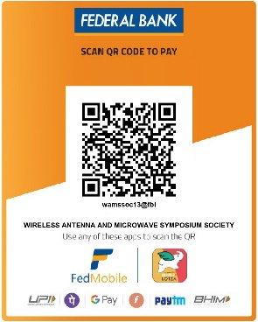

- Please mail the following documents to the mail id “wamssocietymember@gmail.com”

1. Biodata of the applicant
2. Filled and signed copy of the Membership Form
3. Proof of electronic transaction of requisite Membership Fee
4. One latest passport size photograph of the applicant

